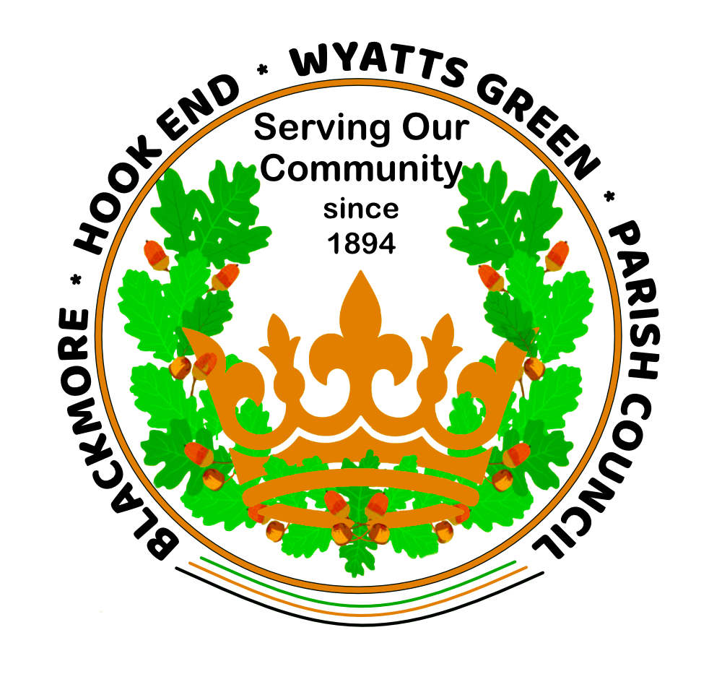

BLACKMORE, HOOK END & WYATTS GREEN PARISH COUNCIL
MINUTES
Of the Annual Meeting of the Blackmore, Hook End &
Wyatts Green Parish Council held on
THURSDAY 20TH JUNE 2024 at 7.30pm
At Tipps Cross Remembrance Hall

Vice Chairman Cllr Swettenham opened the meeting and welcomed all attendees.

MEMBERS PRESENT: Cllrs J Swettenham, K Bennett, H Cannon, V Dean, T Hinton, K Parkinson, H Eltham, N McCarthy, T Lockhart, Mrs R Nelson, RFO (deputising for Clerk).

0025 APOLOGIES FOR ABSENCE – Cllrs T Thomas, J Clarke, R Keeble, K Wood,
Mrs S Clapham, Parish Clerk

0026 APPROVAL OF MINUTES – 16th May 2024
The minutes were signed by the Chairman as a correct record with no amendments.

0027 DECLARATION OF INTEREST (for items on the agenda) – Cllr Cannon declared an interest under item 0041 - Blackmore Village Hall. Cllrs Cannon and Bennett declared an interest under the same item as they represent the Blackmore Parochial Trust.

0028 OPEN FORUM – None

0029 Progress Check/ReporT- None

0030 Correspondence/Communications-
a) Defibrillators - Mrs Nelson reported that a letter had been received regarding use of the defibrillators – action was deferred until the Clerk returns from holiday.Action: Clerk
b) Deal Tree crossroads - On behalf of a resident, Cllr Keeble had reported concern about the number and seriousness of accidents at the Deal Tree crossroads. The Clerk is asked to write to Highways (copied Cllr Wagland and Borough Councillors) regarding the need for verges to be cut to improve sightlines and requesting them to review the problem with regular accidents at this accident blackspot. It was noted that the junction falls within the three Parishes of Doddinghurst, Blackmore and Kelvedon Hatch. The Clerk is asked to first contact Deal Tree Surgery to encourage them to make similar representations to Highways. Ms Nikola Evans’ email to be acknowledged by the Clerk. Coincidentally, it was reported that the VAS signs are not operating on the Blackmore Road into Blackmore, Nine Ashes Road and also Wyatts Green Road. Action: Clerk
c) Street naming of R25 - An email had been received from James Owen, BBC re street naming and numbering of Andersons development (R25). The developer has proposed to Brentwood BC the street name of Fitzroy Close. This had been mentioned by Mr Chilvers at the May PC meeting and the Council now formally accepted this proposal.
Note: Subsequent to the meeting, the RFO has informed BBC of the Council’s agreement to the proposed name.

0031 Reports of Borough & Essex County Councillors-
No Borough or County councillors were present.

POLICY & RESOURCES-
0032 Finance - Payments made online:
S Clapham –
Pension -
HMRC –
Mrs R Nelson –
Total Landscapes - £1,120 plus VAT – various seating installations
John Sharpe - £586.00 – various maintenance works carried out
The Defib Store – replacement smart pads for defibrillator - £122 plus VAT
Castle Water – supply to War Memorial - £7.14 + VAT
Castle Water – supply to Allotment Garden - £14.50 + VAT
Trevor Brown – internal audit fee - £422.29
M D Landscapes – May grass cutting - £1,230.78 + VAT
Blackmore Village Hall – agree part payment for new cricket roller - £2,616
EALC – training course for Cllr Eltham - £200 + VAT
Interact – Clerk’s telephone - £35.42 + VAT (April invoice)
Interact – Clerk’s telephone - £35.42+ VAT (May invoice)
Tipps Cross Remembrance Hall – office rent - £287.50
Lawn Doctor – seed and sand for Walter Hobbs playing fields - £7,832 + VAT

Payments made on the PC Credit Card: Printer cartridge (via Amazon) £41.46 inc. VAT

Approval was given to the purchase of vehicle tax for Blackmore minibus via DVLA at a cost of £165. Action: Clerk

Cash drawn: Nil
Transfers: –
Memberships:-
Income/receipts/Reimbursements:

0033 Financial Report to 31st May 2024
The reports were received and approved as circulated.

0034 Financial Powers:
a) Presentation of the end of year accounts for 2023-24 - These had been circulated in draft form to Councillors and audited by the Internal Auditor. They are presented, without change, to the meeting for signature. Cllr Swettenham and Mrs Nelson signed these on behalf of the Council.
b) Internal Audit – Following the audit on Wednesday 22nd May, the auditor’s report had been received and had been circulated to Councillors. The Auditor, Mr Brown, had not raised any issues of concern. The Chairman thanked the Clerk and the RFO for their work towards the audit.
c) Receipt and signature of Annual Governance and Accounting Statement (AGAR) – The RFO had prepared the AGAR in readiness for submission to the External Auditor. In line with statutory requirements, Section 1 – the Annual Governance Statement and Section 2 – the Accounting Statement were signed by the Chairman and RFO.

PLANNING COMMITTEE-
0035 a) The following applications had been considered at the meeting on 3rd June 2024:-
24/00478/HHA – Bon Accord, Wyatts Green Road, no objections
24/00552/HHA – Blackmore Mill House, Hay Green Lane, no objections
24/00513/HHA – Bluebell Cottage, Outings Lane, objection
24/00459/HHA – Standing Stone, Beehive, Chase, objection (subsequently refused)
Cllr Lockhart is attending the BBC Planning & Licencing meeting on 9th July to speak on behalf of the residents at Bluebells, Second Avenue.
0036 b) Several Councillors and residents had reported that a large mobile home had been sited in the back garden of the Bull Public House in Church Street. Cllr Lockhart informed the meeting that he had met with the owner of the Bull, Mr D Keeble, who confirms that he is now intending to have the site refurbished. The mobile home is to be used by a security team during the refurbishment process and Mr Keeble stressed that it is a temporary arrangement until the work is complete. Cllr Lockhart informed Mr Keeble that he might need to apply for planning permission for the mobile home. It is understood that Mr Keeble intends to convert the building into an executive house. He is liaising with Ms Corrie Newell, an architect with the Historic Buildings Consultancy prior to submitting plans to BBC. No further Parish Council action can be taken at this stage, until plans are submitted.

PARKS & OPEN SPACES (POS)-
The minutes of the meeting held in person on 17th June 2024 at 10.00am were circulated prior to today’s meeting. The Minutes were accepted and the following items were discussed/approved:

0037 Walter Hobbs-
All in accordance with the Committee minutes circulated. No referrals.

0038 Ted Marriage-
All in accordance with the Committee minutes circulated. No referrals.

0039 Mill Lane- All in accordance with the Committee minutes circulated.

0040 Millennium Park - All in accordance with the Committee minutes circulated.

0041 Blackmore Village Hall - Cllr Cannon reported that the Blackmore Football Club & Football Association have requested a form of contract/agreement/lease for the use of Walter Hobbs field for a 10 year period. This is needed to support the Football Club’s application for grant finance for refurbishment of the changing room at the Blackmore Complex. Cllr Bennett explained that the playing field land was originally owned by Walter Hobbs and the Service Lane entrance & the village hall and car park land was owned by Mr Ted Marriage. Walter Hobbs donated his land to the Blackmore Parochial Trust which leased the land to the Parish Council specifically for recreational use, thereby ensuring that the Trust received a regular income. An agreement had been drawn up in 1965 identifying the land and buildings and laying down the terms and conditions of its use and management. Since that time, the Parish Council has been custodian trustee for the Blackmore Village Hall complex.
During the intervening years, two people have asked for a lease to enable them to make a profit from the land (the second one being a café/restaurant). Under the terms of the original agreement, both these requests were rejected.
The Parish Council has never allowed any third party to have a lease or contract covering the land, especially if this was of an exclusive nature (as implied by the Football Club’s request). Cllr Cannon confirmed that the Village Hall currently has Terms of Conditions agreements with teams using the facility but such “licences”/terms & conditions would be different from a full Lease. Indeed, since the Blackmore Football Club has the majority use of the playing fields, such agreements with other groups tend to have lapsed.
The Chairman considered that the Parish Council should obtain legal advice to ensure that any agreement did not restrict the use of the field solely to the football club. For this reason, the wording “exclusive use”, as required by the football authorities, may not be acceptable.
Cllr Swettenham asked the meeting if they wished to move to obtaining legal advice. Before that time, Cllr Cannon recommended a meeting between Cllrs Swettenham, Keeble, Cannon, Bennett, Parkinson, the Clerk and two members of the Village Hall Committee (probably Messrs Caton and Blackwell). It was agreed that a formal proposal is required from the Blackmore Football Club and the Football Association, stating their precise requirements regarding use of the field. Following receipt of this, the Parish Council will seek legal advice to ensure that any actions or agreements entered into by the Parish Council with the Blackmore Football Club were compliant with the Council’s obligations under the Trust Deed which governs the Walter Hobbs field.

It was noted that the developer of R25, Andersons, has offered to move earth from the existing bund and lay a surface of Type 2 or crushed concrete, free of charge. They will also install trunking for new lighting (to be organised by Blackmore Village Hall).

GENERAL PARKS & OPEN SPACES-

0042 Red Rose Lane/Orchard Piece development (R26) - Mrs Nelson requested names of Councillors who wished to attend the meeting with Crest Nicholson and the BVHA on 2nd July. Cllr Keeble has confirmed that he will attend and Cllrs Cannon and Swettenham will join him. Action: Clerk to inform BVHA

0043 Fingerpost – Blackmore roundabout - Cllr Lockhart had obtained a quotation from a Romford company for a new Fingerpost on the Blackmore mini-roundabout (and for an additional finger missing elsewhere). This purchase, at a cost of £2,300 was proposed by Cllr Parkinson, seconded by Cllr Hinton and unanimously approved.

0044 CLERK’S REPORT-

- Zoom meetings – the Clerk had circulated instructions from NALC/EALC about ceasing the use of Zoom for Committee meetings. In line with this advice, POS meetings have recommenced in person.
- Internet connection to Tipps Cross - Cllr McCarthy reported that Gigaclear, who have until now provided the free internet service to Tipps Cross Remembrance Hall, wish to change the current arrangement. He has been approached by the Association of South Essex Local Authorities who are keen to roll out fast internet to village halls and they are prepared to provide such a service, free of charge for the next three years. This would require a small aerial to be installed on the roof of the hall, similar to that at Blackmore Village Hall. Cllr McCarthy recommended that this service be transferred later in the year and confirmed that the official order will be placed by Tipps Cross Trust. Action: Cllr McCarthy

0045 Date of next meeting(s):
POS – Monday 15th July 24– 10.00am – Tipps Cross Remembrance Hall
PC – Thursday 18th July 24 – 7.30pm – Tipps Cross R Hall Committee Room.
Planning – To be confirmed, subject to receipt of planning applications.

INFORMATION EXCHANGE/NEXT AGENDA ITEMS- No items.
Following an enquiry from Cllr Eltham, the Clerk is asked to include weed removal around the mini-roundabout and on the village streets generally, on the next NATS visit.
Action: Clerk

CLOSE OF MEETING -
There being no further business, the meeting was closed by the Chairman at 8.55 pm.

Signed:__________________________________ Dated: _________________________

